5.Write a java program that takes the purchase amount as input and calculate the final payable amount after applying the discount.

1. If the purchase amount is less the 500.

Output:

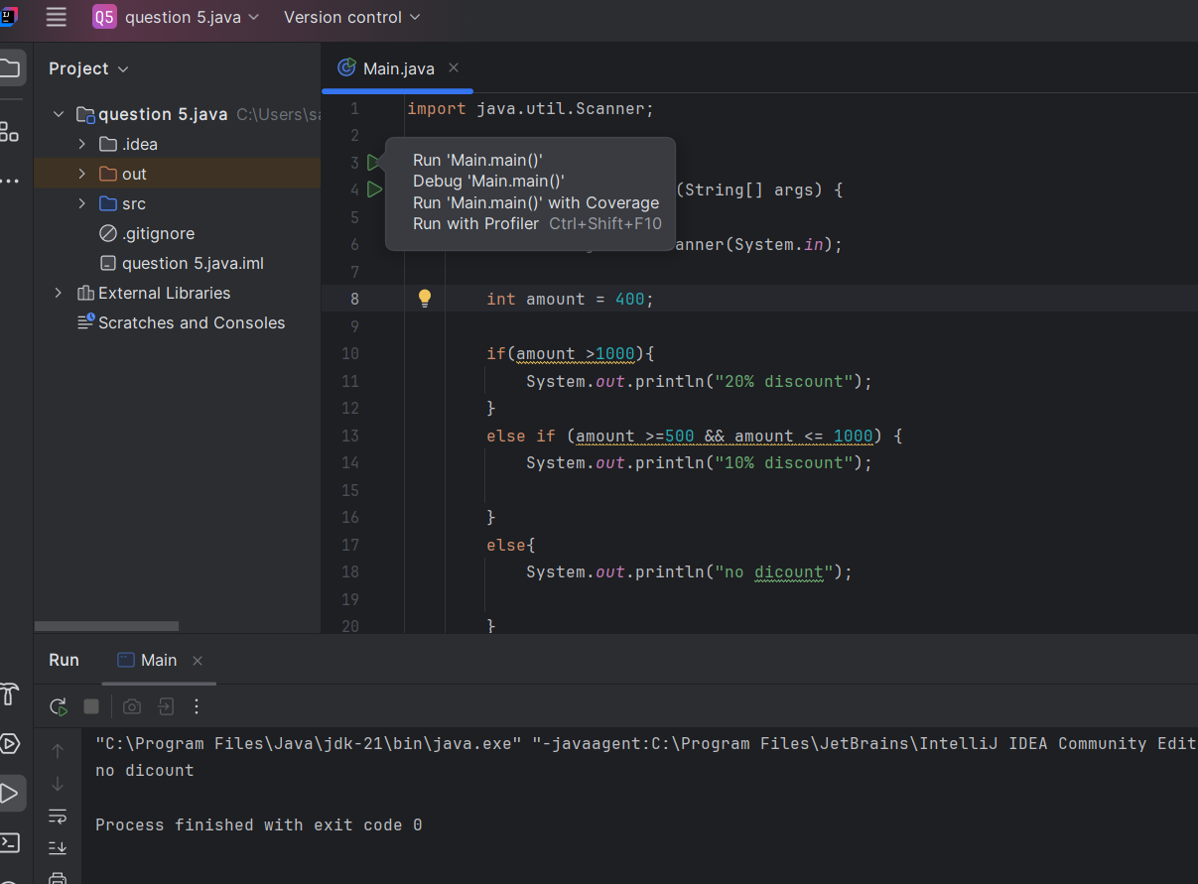

2.if the purchase amount between 500 to 1000

Output:

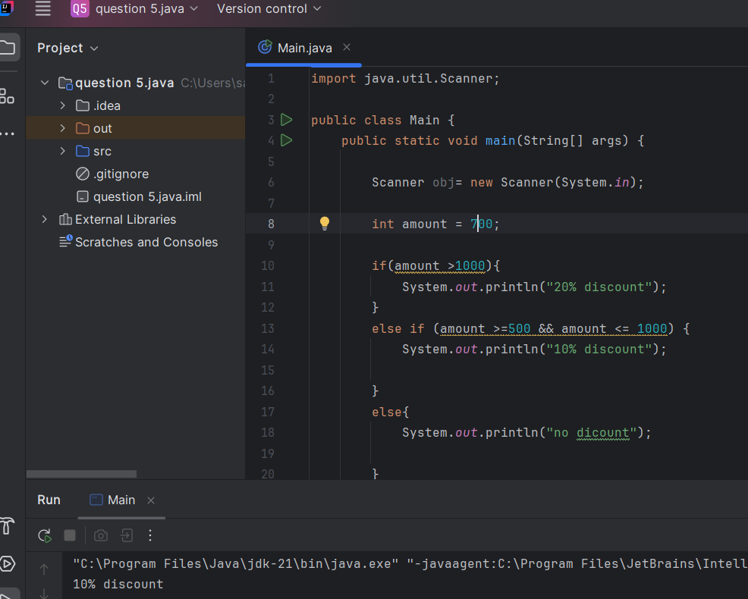

3.if the purchase amount is greater than 1000

Output:

